**Physical Media**

**Coaxial Cable**

**Coaxial cable** is a type of copper cable specially built with a *metal shield* and other components engineered to *block signal interference(parazit, karışma)*. Thus, coaxial cable shields data transmissions from *electromagnetic interference (EMI)*. It is primarily used by cable TV companies to connect their satellite antenna facilities to customer homes and businesses and also to connect a cable modem to an Internet service provider (ISP). This connection enables a computer to access the Internet.

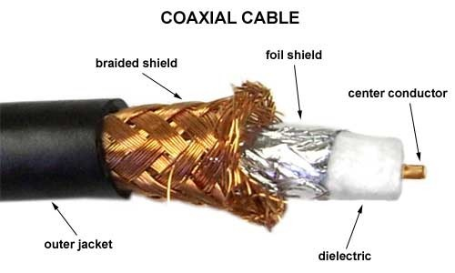

The cable is named coaxial because the central copper wire and the braided metal shield share a common axis or centerline. The metal wire is generally covered sequentially from the center to the outside by insulation (dielectric), foil shield, braided metal shield, and jacket layers. Many of these cables or pairs of coaxial tubes can be placed in a single outer sheathing and, with repeaters, can carry information for a great distance.

**💡Tip:**

* Coaxial cable was invented in 1880 by English engineer and mathematician Oliver Heaviside, who patented the invention and design that same year. AT&T established its first cross-continental coaxial transmission system in 1940.

**Advantages of coaxial cable**

* Inexpensive
* Easy to wire and install
* Easy to expand
* Good resistance to EMI (Electromagnetic Interference)
* Up to 10Mbps capacity
* Durable

Another **benefit** of coaxial cable that it can be installed next to metal objects without losing power, unlike other types of transmission lines.

The main **disadvantage** of using the coaxial cable is that a single cable failure can take down an entire network.

**Thin Ethernet** (also referred to as *Thinnet* or *10Base2*) and **Thick Ethernet** (also referred to as *Thicknet* or *10Base5* are coaxial cable types. They have the same properties except for the thickness of the cables is different. (Thinnet is only about 5 mm, or 2/10″, diameter coaxial cable).

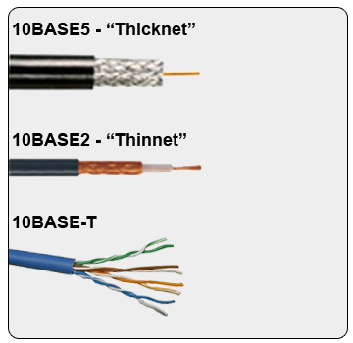

If you use Thinnet (or Thicknet) cable, you’ve got to use BNC connectors to attach stations to the network.

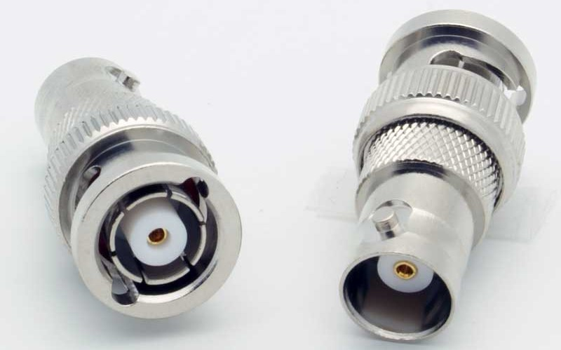

**Male and female BNC connectors**

The **F connector**, or **F-type** connector, s a form of coaxial connector that is used for cable TV.

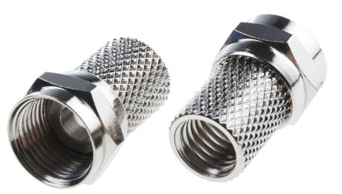

**Male F-type connector**

**Twisted-Pair Cable**

A **twisted-pair** cable is a type of cable made by putting two separate insulated wires together in a twisted pattern and running them parallel to each other. This type of cable is widely used in different kinds of data and voice infrastructures.

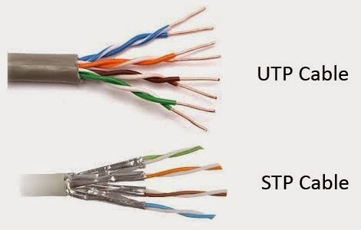Two different types of twisted pair cable, **unshielded twisted pair (UTP)** and **shielded twisted pair (STP)** are used in different kinds of installations. **UTP** is common in *Ethernet* installations, while **STP** is used in various kinds of networks to *prevent crosstalk and electromagnetic interference*.

In general, twisted-pair cabling may be preferred over a common alternative, coaxial cable, for different reasons. Coaxial cable involves a single, thicker wire. Twisted pair has a more accommodating bend(bükme,dirsek) radius, is easier to terminate, and provides more versatility(çok yönlülük) in selecting network topologies.

Ethernet cable types are described using a code that follows this format:

**N <Signaling> X**.

The **N** refers to the *signaling rate in megabits per second*. **<Signaling>** stands for the *signaling type*—either baseband or broadband *(will be discussed in the following lessons)*—and the **X** is a *unique identifier* for a specific Ethernet cabling scheme.

Here’s a common example: 100BaseX. The 100 tells us that the transmission speed is 100 Mb or 100 megabits. The X value can mean several different things; for example, a T is short for twisted-pair. This is the standard for running 100-megabit Ethernet over two pairs (four wires) of Category 5, 5e, or 6 UTP.

So why are the wires in this cable type twisted? Because when electromagnetic signals are conducted on copper wires in close proximity—like inside a cable—it causes interference called crosstalk. Twisting two wires together as a pair minimizes interference and even protects against interference from outside sources. This cable type is the most common today for the following reasons:

* It’s cheaper than other types of cabling.
* It’s easy to work with.
* It allows transmission rates that were impossible 10 years ago.

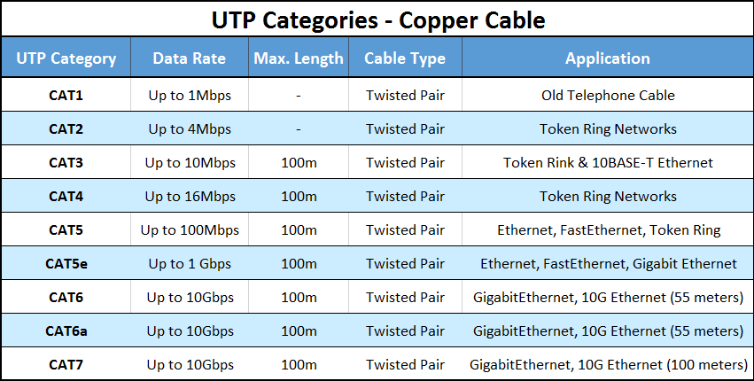

UTP Categories

BNC connectors won’t fit very well on UTP cable, so a registered jack (RJ) connector should be used. The connector used with UTP cable is called RJ-11 for phones that use four wires; RJ-45 has four pairs (eight wires), as shown in the below figure.

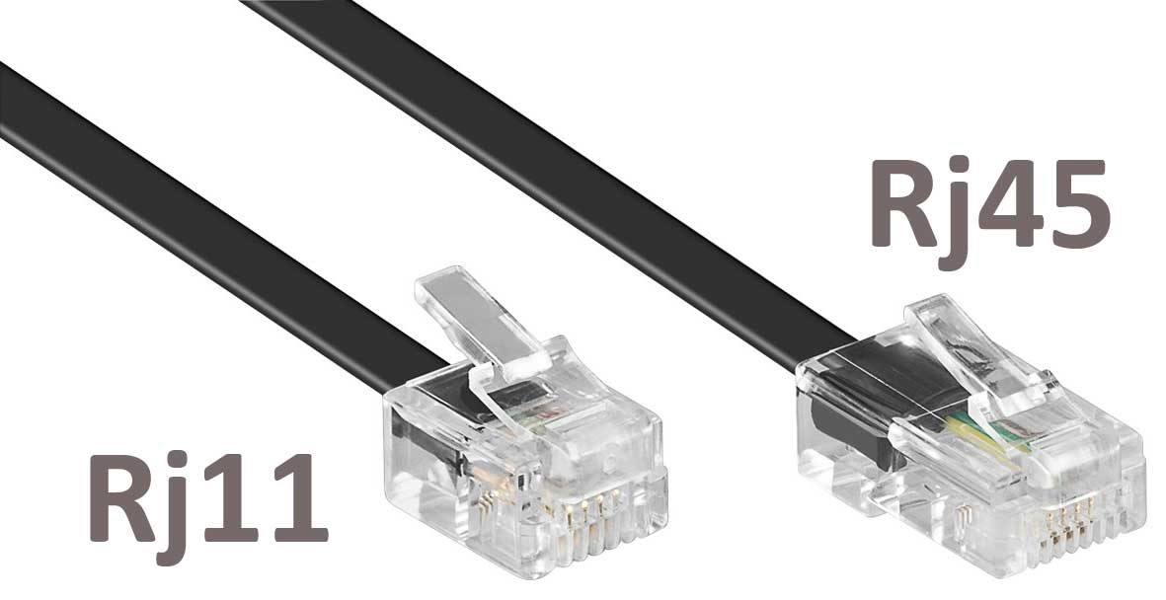

**RJ-11 & RJ-45 Connectors**

**Fiber-Optic Cable**

**Optical fiber** is a very thin strand of pure glass that acts as a waveguide for light over long distances. It uses a principle known as *total internal reflection*.

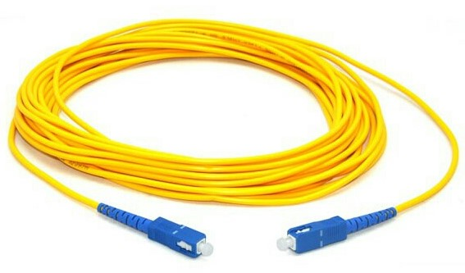

Fiber optic cable is actually composed of two layers of glass: The **core** which is thinner than hair *carries the actual light signal*, and the **cladding** is a *layer of a glass surrounding the core*. Most fibers operate in duplex pairs: one fiber is used to transmit and the other is used to receive. But it is possible to send both signals over a single strand.

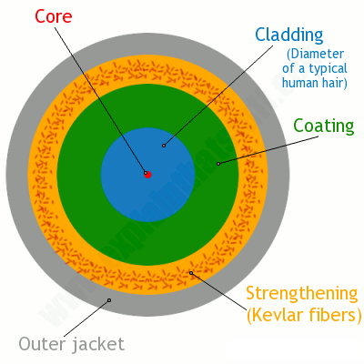

**Fiber-Optic Cable Construction Layers**

Because fiber-optic cable transmits digital signals using light impulses rather than electricity, it’s **immune to EMI and RFI**. Fiber cable allows light impulses to be carried on either a glass or a plastic core. Glass can carry the signal a *greater distance*, but plastic *costs less*.

Fiber-optic cable has advantages and disadvantages just like the other cable types.

Here are the advantages:

* It’s completely immune to EMI and RFI.
* It can transmit up to 40 kilometers (about 25 miles).
* It has a high carrying capacity (very broad bandwidth, THz or Tbits/s)
* It has very low transmission losses (<0.2dB/km, cf1dB/km microwave, 10db/km twisted copper pair)
* It does not produce heat

And here are the disadvantages:

* It’s difficult to install.
* It’s more expensive than twisted-pair.
* Troubleshooting equipment is more expensive than twisted-pair test equipment.
* It’s harder to troubleshoot.

There are two main types of fiber optic cables: **Single-Mode Fiber (SMF)** and **Multi-Mode Fiber (MMF)**. The difference is basically in the *size of the core*. **MMF** has a much wider core, allowing multiple modes (or “rays”) of light to propagate. **SMF** has a very narrow core which allows only a single mode of light to propagate. Each type of fiber has different properties with its own advantages and disadvantages.

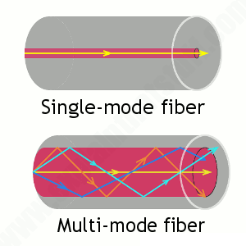

**Transceivers**

A **transceiver (TRX)** is a device that can transmit and receive signals. Usually, a transceiver contains both a transmitter and a receiver, both of which share common circuitry(devre). However, if the transmitter and receiver only share a common housing and nothing else, the device is called a **transmitter-receiver**. Transceivers are extremely important in the history of technology, as they have paved the way for many inventions such as two-way radios, mobile phones, and the internet.

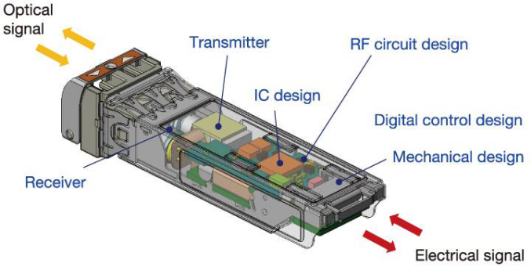

**Fiber Transceiver**

Transceivers can be found in radio technology, telephony as well as Ethernet in which transceivers are called **Medium Attachment Units (MAUs)**.

**Media Converters**

Sometimes, we need to convert from one media type to another. Maybe we need to go from one mode of fiber to another mode or we need to go from fiber to Ethernet.

* **Single-Mode Fiber to Ethernet** - These devices accept a fiber connector and an Ethernet connector and convert the signal from Ethernet and single-mode fiber.

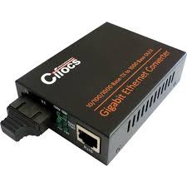

**Single-Mode Fiber to Ethernet Converter**

* **Multimode Fiber to Ethernet** - These devices accept a fiber connector and an Ethernet connector and convert the signal from Ethernet and multi-mode fiber.

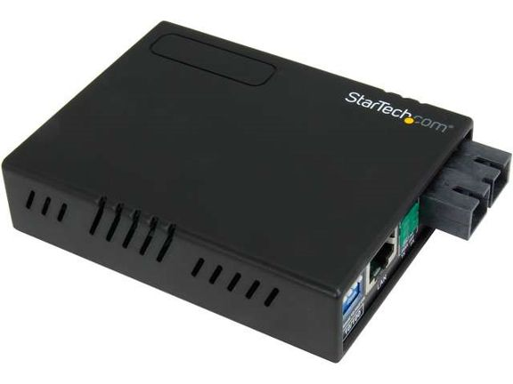

**Multimode Fiber to Ethernet Converter**

* **Fiber to Coaxial** - These devices accept a fiber connector and a coaxial connector and convert digital signals from optical to coax.

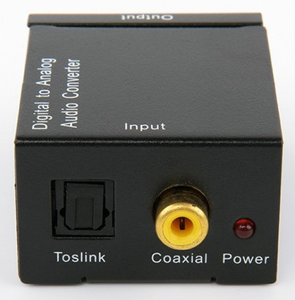

**Fiber to Coaxial Converter**

* **Single-Mode to Multimode Fiber** - These devices accept a single-mode fiber connector and a multimode fiber connector and convert the signals between the two.

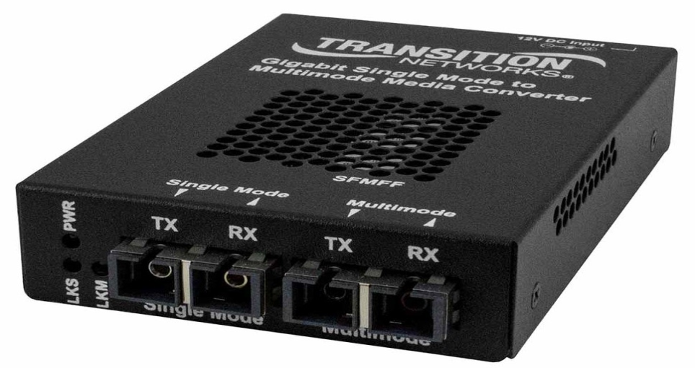

**Single-Mode to Multimode Fiber Converter**

**Cable Properties**

**Transmission Speeds**

Network administrators can control the speed of a network to meet the network’s traffic demands based on the selected *cable or fiber type* and the *network topology*.

Admins usually permit or would like to have, transmission speeds of up to 10 Gbps or higher on the core areas of their networks that connect various network segments. In the distribution and access areas, where users connect to switches, it’s typically 100 Mbps per connection, but transmission speeds are creeping up(sürünmekte) because the traffic demand is getting higher.

**Distance**

Decision factors used in choosing what type of cable to use often come down to the topology of a network and the distance between its components. Some network technologies can run much farther than others without communication errors, but all network communication technologies are **prone to attenuation(**zayıflamaya eğilimli)—the degradation of a signal due to the medium itself and the distance signals have to travel. Some cable types suffer from attenuation more than others. For instance, any network using twisted-pair cable should have a maximum segment length of only 328 feet (100 meters).

**Duplex**

All communications are either **half-duplex** or **full-duplex**. The difference is whether the communicating devices can “*talk*” and “*listen*” at the same time.

During **half-duplex** communication, a device can either send communication or receive communication, but not both at the same time. Think walkie-talkie—when you press the button on the walkie-talkie, you turn the speaker off and you can’t hear anything the other side is saying.

In **full-duplex** communication, both devices can send and receive communication at the same time. This means that the effective throughput(verim) is doubled and communication is much more efficient. Full duplex is typical in most of today’s switched networks. We'll discuss full and half-duplex in more detail in the section “The Current Ethernet Specifications.”

**Frequency**

Each cable type has a specified maximum frequency that gives you the transmission bandwidth it can handle. Cat5e cable is tested to 100 MHz maximum frequency and can run 1 Gbps signals for relatively short distances. That’s maxing it out, but it’s still good for connecting desktop hosts at high speeds. On the other hand, Cat6 is a 250 MHz cable that can handle 1 Gbps data flow all day long with ease. Cat 6 has a lot more twists and thicker cables, so it’s best used when connecting floors of a building.

**💡Tips:**

* Although a signal is measured as **bandwidth**, the capacity to carry the signal in a cable is measured as **frequency**.